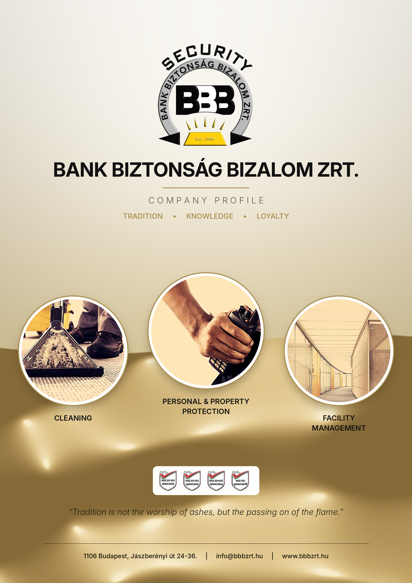


ABOUT US

The Company's legal predecessor was founded on 1 March 1994 as Bank Biztonság Bt. Due to the continuous growth of our activities, a change of corporate form soon became necessary: first a limited liability company (Kft.), then from 1 September 1996 a company limited by shares under the name Bank Biztonság Bizalom Zrt. – which is how our Company operates today.
OUR VISION

Our main goal is to maintain financial stability while adapting to our clients' needs and providing all the conditions necessary for a consistently high standard of service.
In our work, our primary aim is to strengthen the sense of security of our clients, guests and employees while maintaining the highest level of professionalism. We carry out the tasks entrusted to us proactively, flexibly and fully in line with our clients' requirements, often delivering added value.


OUR SERVICES
A complete range of services
Personal and property protection
- Comprehensive property protection of shopping and entertainment facilities.
- Information desk, reception, armed security guard and gatekeeping services at companies, office buildings and institutions.
- Security and property protection information and consultancy.
- Security audits of companies. Risk analysis, protection plans, and personal and facility protection proposals.
- Close protection services.
- Design, installation and operation of security technology systems.
- Event security.
- Armed cash and valuables escort, courier services.
- Protection of critical infrastructure.
- Tasks requiring special qualifications.
- Use of online KPI monitoring systems.
Facility management, building cleaning
- Comprehensive facility management services.
- Daily cleaning of public buildings and offices, deep cleaning.
- Cleaning performed with special (rope access) techniques.
- Carpet cleaning, machine floor cleaning.
- Park and garden maintenance, gardening work.
- Special cleaning tasks.

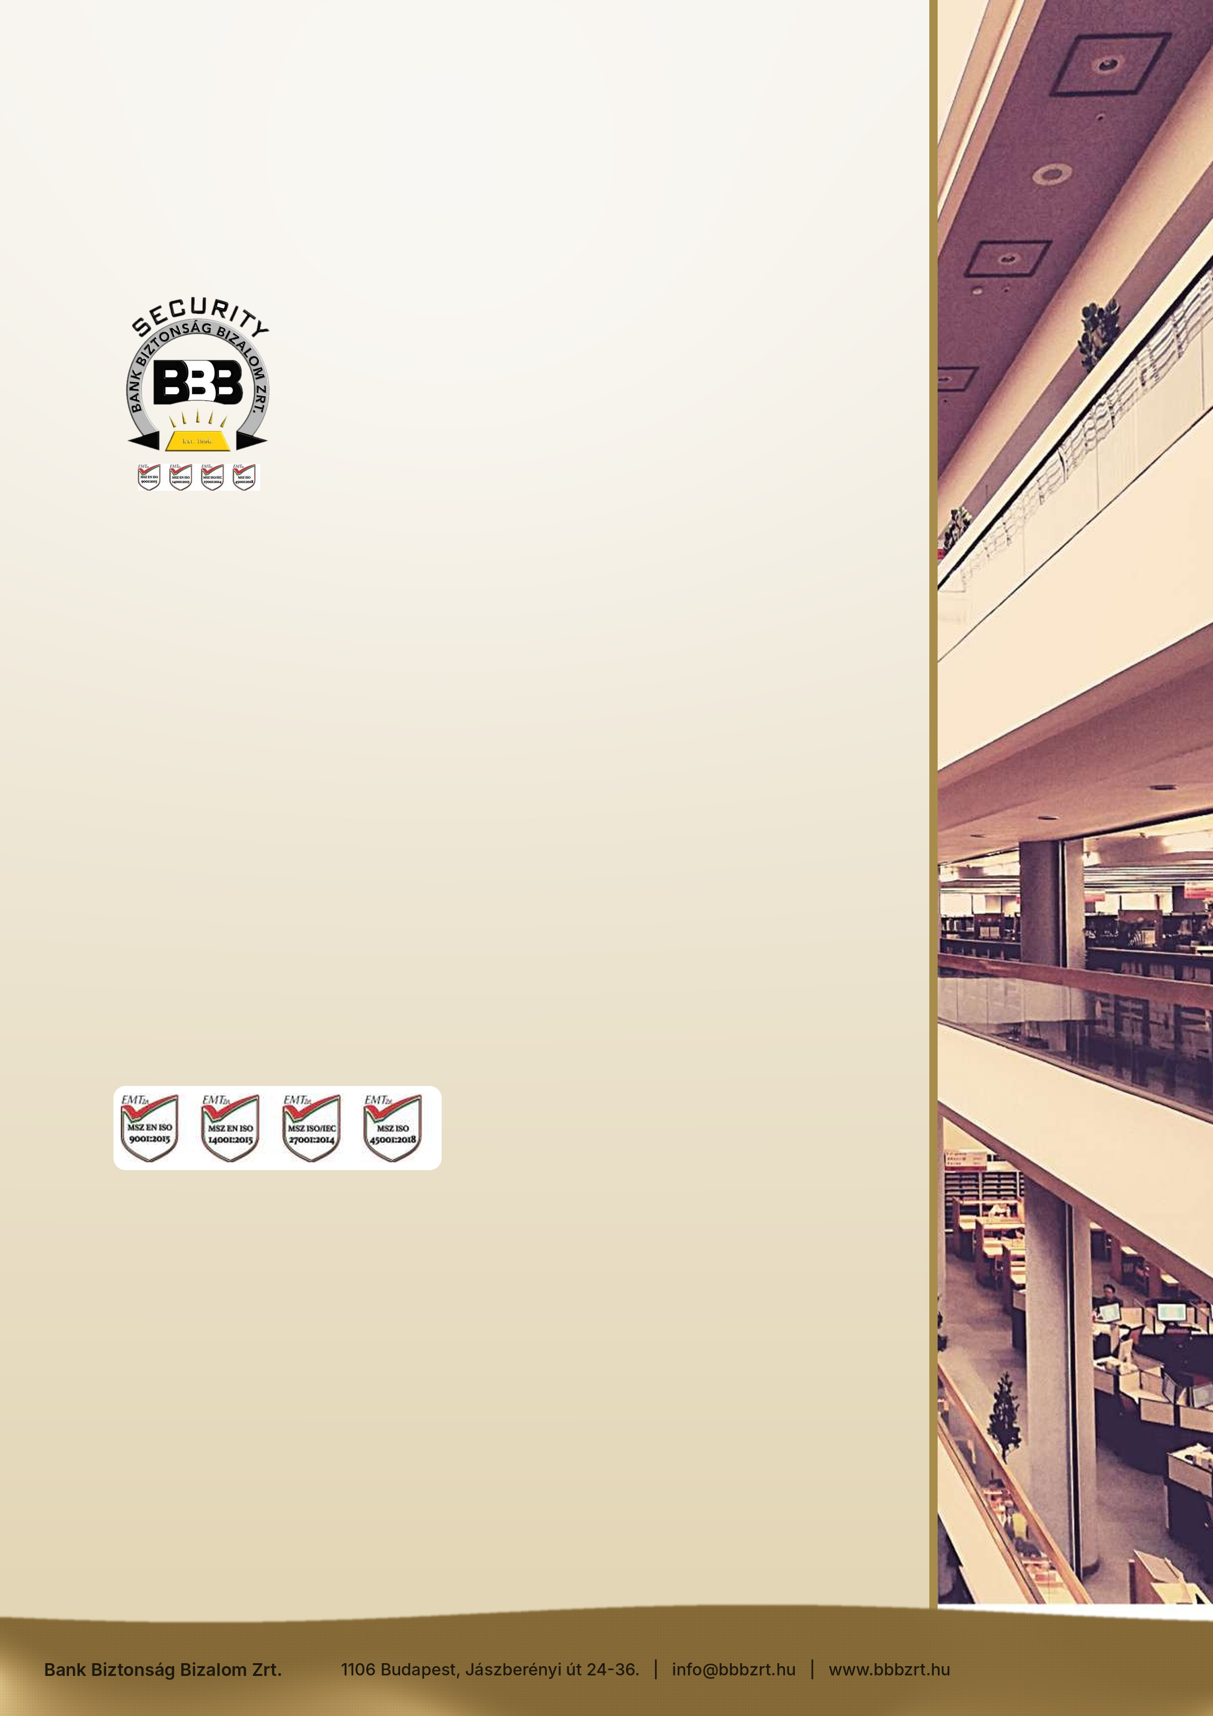
COMPETENCES

To provide the services listed, our Company holds the Police Authority Licence required by law for personal and property protection activities, a Site Security Certificate, and the necessary liability insurance.
Our Company is a member of the Hungarian Employers' Association of Security Enterprises, VOSZ (National Association of Entrepreneurs and Employers) and the Hungarian Security Association, and is registered with the Budapest Chamber of Commerce and Industry.
CERTIFICATIONS

MSZ EN ISO 9001:2015,
MSZ EN ISO 14001:2015
MSZ ISO/IEC 27001: 2013
MSZ ISO 45001:2018
MSZ ISO 37001:2019


REFERENCES

We have gained significant experience in the complex security tasks of large-scale facilities, including the Ajka and Inota sites of Bakonyi Erőmű Zrt., the Palace of Arts (Müpa), the Papp László Budapest Sports Arena and GYSEV Cargo Zrt., as well as securing the sites of new developments such as the National Theatre, Millennium City Centre, Vodafone Tower, Kőérberek-Tóváros residential park, Castrum House, Marina Part, Infopark, Decathlon Soroksár, Syma Hall, Korda Film Park Etyek, MÁV Nosztalgia Kft. and the Mayor's Office of Ferencváros (District IX, Budapest).
Our clients have included several owners and operators of leisure and tourism facilities; our staff provided security and property protection at Hotel Balneo (Zsórifürdő), Hotel Greenfield (Bükfürdő), Hotel Lotus Therme (Hévíz) and Hotel Tiliana (Budapest).
We have continuously provided event security, primarily on behalf of the Papp László Budapest Sports Arena, the Palace of Arts, the Hungarian Railway History Park Foundation, Érd Aréna and Érd Sport Kft.
Through public tenders we were awarded the security services of the Budapest Zoo and Botanical Garden and Rail Cargo Hungaria Zrt., as well as specified security and consignment escort services for National Toll Payment Services Zrt., National Infrastructure Development Zrt., MÁV Zrt., MÁV Start Zrt. and MÁV Service Centre Zrt.
REFERENCES

We currently provide security services at the following sites:
- Rail Cargo Hungaria Árufuvarozási Zrt.
- Gránit Bank Nyrt.
- MÁV Rail Tours Kft.
- ÉTH Érd és Térsége Hulladékkezelési Nonprofit Kft.
- Érd Városgazda Érd Aréna
- Érs Városgazda Irodaház
- Érd Szociális Gondozó Központ
- Vas Megyei Korház Intaháza
- Vas Megyei Korház Celdömölk
- Vas Megyei Korház Körmend
- Vas Megyei Korház Szentgothárd
- Észak -Közép budai Centrum Új Szent János Korház és Szakrendelő
- Fővárosi Ítélőtábla
- Gyöngyös Járásbíróság
- Egri Törvényszék
- Egri Járásbíróság
- Füzesabonyi Járásbíróság
- Hatvani Járásbíróság
- Győri Ítélőtábla
- Szolnoki Törvényszék
- Szombathely Törvényszék
- KNYF - Fővárosi Nyomozó Ügyészség
- KNYF - Győri Regionális Nyomozó Ügyészség
- KNYF - Debreceni Regionális Nyomozó Ügyészség
- Magyar Igazságügyi Akadémia Budapest
- Magyar Igazságügyi Akadémia Balatonszemes
- MKIFKI Magyar Közlönykiadó és Igazságügyi Fordítóközpont Zrt.
- Bayer Mester Zenit Corso Budapest
- Corvin Palace Budapest
- InterContinental Budapest Hotel
- MAVIR Székház Budapest
- MAVIR Albertirsa Vezetékfelügyelőség és 400 KV-os transzformátor állomás
- MAVIR Göd 400/220/120 KV-os transzformátor állomás
- MAVIR Paks 400/220/120 KV-os transzformátor állomás
- Truck Factory Kft. Budaőrs
- AJBH Panoráma Offices Irodaház
- Kormányhivatal Bicske
- Kormányhivatal Martonvásár
- Kormányhivatal Székesfehérvár Béke tér
- Kormányhivatal Székesfehérvár Deák Ferenc utca
- Kormányhivatal Székesfehérvár Dr. Koch László utca
- Kormányhivatal Székesfehérvár Honvéd utca
- Kormányhivatal Székesfehérvár Hosszúséta tér
- Kormányhivatal Székesfehérvár József Attila utca
- Kormányhivatal Székesfehérvár Mátyás király körút
- Kormányhivatal Székesfehérvár Piac tér
- Kormányhivatal Székesfehérvár Sörház tér
- Kormányhivatal Velence
- NAV Dunújváros Október 23.-a tér
- NAV Székesfehérvár Bakony utca
- NAV Székesfehérvár Dr. Koch László utca
- NAV Székesfehérvár Kégl György utca
- NAV Székesfehérvár Király sor
- NAV Székesfehérvár Mátyás körút 4 A/B
- NAV Székesfehérvár Mátyás körút 8
- NAV Székesfehérvár Prohászka utca
- NAV Székesfehérvár Szekfű Gyula utca
- NAV Tatabánya Komáromi út
- NAV Tatabánya Vértanúk tere
- Demecser Kézilabda Munkacsarnok
- Galyatető Turistaház
- Mátraházi Edzőtábor és Pagoda
- NAV Budapest Hajnóczy József
- NAV Budapest Harmat utca
- NAV Budapest Hősök fasora
- NAV Budapest Madarász utca 5/A
- NAV Budapest Munkácsy Mihály utca
- NAV Gödöllő
- NAV Szigetszentmiklós
- NAV Vác Dr. Csányi László körút
- NAV Vác Lemez u.

Among others, our Company performed the cleaning tasks at Bakonyi Erőmű Zrt., WestEnd City Center, Office Building 78, the Millennium Tower I-II-III office buildings, the Papp László Budapest Sports Arena, the Palace of Arts and the Hungarian Railway History Park Foundation. We provided these services independently until the end of 2017; our current cleaning tasks are carried out with the involvement of a proven, highly experienced subcontractor.

